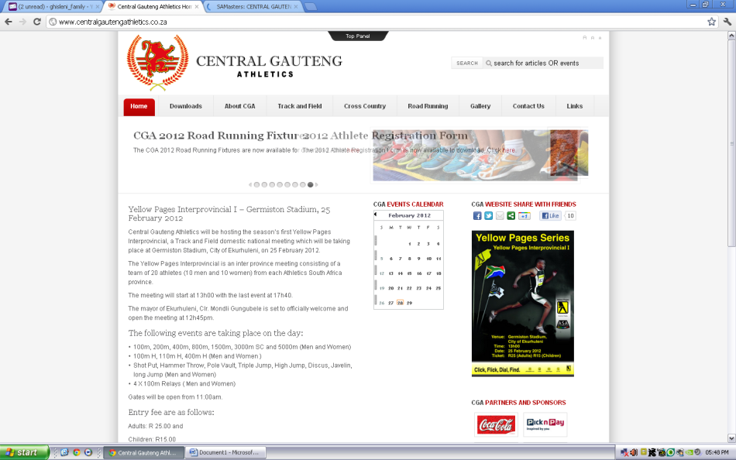

**APPLICATION FOR CENTRAL GAUTENG MASTERS PROVINCIAL COLOURS**

**AANSOEK VIR SENTRAAL GAUTENG MEESTERS PROVINSIALE KLEURE**

|  |  |  |  |  |  |  |  |  |  |  |  |  |  |  |  |  |  |
| --- | --- | --- | --- | --- | --- | --- | --- | --- | --- | --- | --- | --- | --- | --- | --- | --- | --- |
| NEW/NUWE | | |  | | YEAR/JAAR | | |  | | | RE-AWARD/HERTOEKENNING | | | | | |  |
| FIRST NAME / VOORNAME | | | | | | | | | | | SURNAME / VAN | | | | | | |
| GENDER /  GESLAG | M | | | F | | DATE OF BIRTH /GEB.DATUM | | | | | | | PROVINCE / PROVINSIE | | | | |
| POSTAL ADDRESS/POSADRES | | | | | | | | | | EMAIL / EPOS | | | | | | | |
| TEL NO | | | | | | | | | | CELL NO | | | | | | | |
| AGE GROUP /  OUD.GRP | | EVENT(S)  ITEM(S) | | | | | BESTE VERTONING / BEST PERF. | | AGE GRP STD / OUD.GRP STD | | | Venue/  Plek | | Meeting/  Byeenkoms | | Date: D/M/Y  Datum:  D/M/J | |
| Eg. M50 | | 100m | | | | | 14.70 | | 13.54 | | | Bloemfontein | | FS Champs | | 05/11/2009 | |
|  | |  | | | | |  | |  | | |  | |  | |  | |
|  | |  | | | | |  | |  | | |  | |  | |  | |
|  | |  | | | | |  | |  | | |  | |  | |  | |
|  | |  | | | | |  | |  | | |  | |  | |  | |
| Signature / Handtekening: | | | | | | | | | | Date joined CGMA/datum aangesluit:  Day….... Month …..... Year.........  Dag ….....Maand ….....Jaar........ | | | | | | | |
| For Official use only/slegsamptelikegebruik | | | | | | | | | |  | | | | | | | |
| Verification of membership: Date Joined:  Bevestiging van lidmaatskap: Datum aangesluit: | | | | | | | | | | Day….... ..Month ...….. Year.........  Dag …..... Maand ….....Jaar......... | | | | | | | |
| CGMA committee decision: | | | | | | | | | | Approved/Aanvaar | | | | | Afgekeur/Declined | | |
| If declined, give brief reason: | | | | | | | | | |  | | | | | | | |

**Closing date for applications:**

**Email to/ Epos aan: centralgautengmastersathletics@gmail.com**